Honeywell Enterprise Browser for Windows Mobile

# Camera Button addon

The small tool IBaddBtnCAM.exe will add a Camera button to Enterprise Browser (EB).

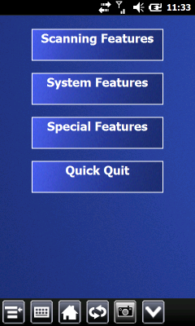 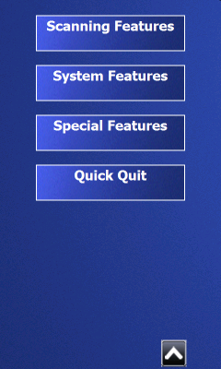

This button starts the existing FullScreenCameraCNx.exe that comes with EB. The button will hide and show with the other buttons.

The tool IBaddBtnCAM.exe has to be started when EB is already running. There is a helper application that starts and ends IBaddBtnCAM.exe automatically with EB: IBinjectDLL.dll

An installation should install IBaddBtnCAM.exe and IBinjectDLL.dll to “\Windows\” on the device.

If the button is used, the Camera app is started. The camera app should be running full screen as FullScreenCameraCNx.exe does. The photo taken is always saved as SnapShot.jpg by FullScreenCameraCNx.

# Helper tool IBinjectDLL.dll

This helper tool has to be copied to \Windows\ on the device and the registry of the device must be changed to inject the DLL with every started process:

REGEDIT4  
[HKEY_LOCAL_MACHINE\System\Kernel]  
"InjectDLL"=hex(7):\  
 5C,77,69,6E,64,6F,77,73,5C,49,42,69,6E,6A,65,63,74,44,4C,4C,2E,64,6C,6C,\  
 00,00

The hex values are nothing else than the name and location of IBinjectDLL.dll, “\windows\ IBinjectDLL.dll”.

Although IBinjectDLL.dll supports further configuration by the registry, these are not used in this context and should not be touched.

# Installation

If no CAB Installation file is provided, install the tools manually:

1. Copy IBinjectDLL.dll to \Windows on the device
2. Copy IBaddBtnCAM.exe to \Windows on the device
3. Change the device registry and add following key:

REGEDIT4  
[HKEY_LOCAL_MACHINE\System\Kernel]  
"InjectDLL"=hex(7):\  
 5C,77,69,6E,64,6F,77,73,5C,49,42,69,6E,6A,65,63,74,44,4C,4C,2E,64,6C,6C,\  
 00,00

1. Reboot the device

If a CAB file is provided then copy the CAB file onto the device and install it by using the mobile File Explorer. Reboot the device manually after the installation

# Requirements

Intermec CK71 and CN51 WEH tested

Enterprise Browser 2.20.01.0129 in PIE, IE6 and HTML5 mode tested